SIGN UP SHEET 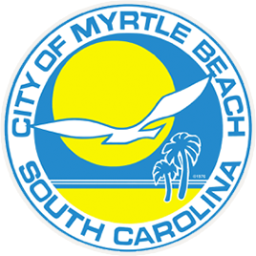 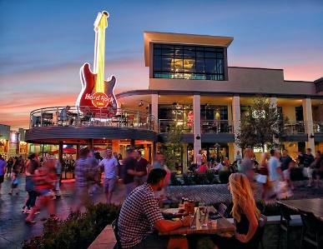
MYRTLE BEACH, SOUTH CAROLINA
MAY 22 – 26, 2023
5 Days/4 Nights Bus trip $800.00 per person double occupancy $1000.00 single occupancy. Package includes: 4 Nights lodging, 4 Breakfasts, 4 Dinners, Fabulous shows at the Carolina Opry & Alabama Theatre. Special guided tour of the historic area of Charleston, SC. Barefoot Landing, Visit “Broadway at the Beach”. Luggage handling, Souvenir gift, and All taxes and gratuities are included. Motorcoach transportation. DEPOSIT OF $250.00 IS DUE ASAP WITH FINAL PAYMENT DUE BY MARCH 31, 2023.
Please complete the below form and return with FULL payment to be included on this trip. If bus is full you will be placed on the waiting list.

Last name/first ___________________________________________
Cell Phone ______________________________________________
Date of birth_________________________
Address___________________________________ Apt #_________
City____________________ State______ ZipCode _________
Spouse name___________________________ Phone _______________
Date of birth_____________
EMERGENCY CONTACT _____________________________________
Phone ______________________________________
EMERGENCY CONTACT _____________________________________
Phone ______________________________________

CANCELLATION & REFUND POLICY: Money will not be refunded unless someone takes your place and after trip is taken. If the trip is cancelled for lack of sufficient interest, the refunds will be made promptly.

