SIGN UP SHEET 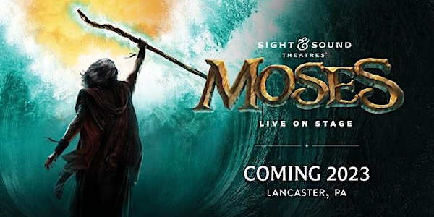
SIGHTS AND SOUND THEATRE “MOSES” MAY 3, 2023
$160.00 PER PERSON THE BUS WILL WAIT FOR NO ONE!!!!!!!!
(includes bus transportation and all gratuities) The bus will leave Kohl’s parking lot 8:00 a.m. with anticipated return to Easton by 6:30 p.m. Enjoy a 11:00 am showing of “Moses” – Set adrift as a baby, Moses is an unlikely hero – until God calls him to lead His people out of Egypt and into the Promised Land. From the banks of the Nile River to the depths of the Red Sea, journey with Moses as he leads God’s people on an amazing adventure through the wilderness, encounters God at the burning bush, and ascends to the top of Mount Sinai. Following the performance, enjoy a lunch smorgasbord style dinner at Hershey Farms Restaurant at 2:15 pm. PAYMENT IS DUE IN FULL BY MARCH 17, 2023.
Please complete the below form and return with FULL payment to be included on this trip. If bus is full you will be placed on the waiting list.

Last name/first ___________________________________________
Cell Phone ______________________________________________
Date of birth_________________________
Address___________________________________ Apt #_________
City____________________ State______ ZipCode _________
Spouse name___________________________ Phone _______________
Date of birth_____________
EMERGENCY CONTACT _____________________________________
Phone ______________________________________
EMERGENCY CONTACT _____________________________________
Phone ______________________________________
CANCELLATION & REFUND POLICY: Money will not be refunded unless someone takes your place and after trip is taken. If the trip is cancelled for lack of sufficient interest, the refunds will be made promptly.

