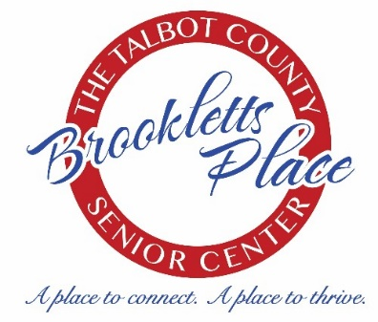 2024

MONDAY | TUESDAY | WEDNESDAY | THURSDAY | FRIDAY
1  9:00 Coffee Hour  9:00 S.A.I.L. Enhance Fitness  10:30 Music w/Melanie  11:00 Advance Beginners  Watercolor  11:00 Tai Chi w/Nathan  12:00 Lunch  12:00 Mahjong  1:00 Guitar & Ukulele Lessons | 2  9:00 Coffee Hour  10:00 Bingocize  12:00 Lunch  12:30 Yarn & Needle Group  1:00 Basic Computer Class  “If you cannot find peace within yourself, you will never find it anywhere else.”  Happy Birthday  Marvin Gaye  April 2, 1939 | 3  9:00 Coffee Hour  9:00 Beginning Oil Painting  10:00 Blood Pressure  Screening  10:30 Wii Bowling  11:00 Duplicate Bridge  12:00 Lunch  1:00 Travel Advisory Meeting | 4  8:30 S.A.I.L. Enhance Fitness  9:00 Coffee Hour  10:00 Bingocize  10:00 ShoGo Mobile  12:00 Lunch  On This Day in History  April 4, 1975  Microsoft is founded as a partnership between Bill Gates and Paul Allen in Albuquerque, New Mexico | 5  9:00 Coffee Hour  9:30 Dance Fitness  10:00 Mahjong  11:00 Tai Chi w/Nathan  11:30 Toastmaster’s  12:00 Lunch  A bus station is where a bus stops. A train station is where a train stops. On my desk, I have a work station.
8  9:00 Coffee Hour  9:00 S.A.I.L. Enhance Fitness  10:00 Crafting with Tonia 11:00 Advance Beginners  Watercolor  11:00 Tai Chi w/Nathan  12:00 Lunch & Learn  w/Melanie  12:00 Mahjong  1:00 Guitar & Ukulele Lessons | 9  9:00 Coffee Hour  10:00 Bingocize  12:00 Lunch w/CARPE DIEM  12:30 Yarn & Needle Group  1:00 Basic Computer Class  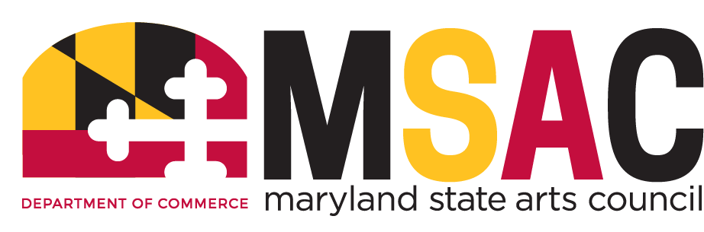 | 10  8:30 Commission on Aging 9:00 Coffee Hour  9:00 Beginning Oil Painting  10:00 Stress Reduction  Awareness Workshop  w/Michelle  10:30 Wii Bowling  11:00 Duplicate Bridge  11:30 Dutch Lunch Out  “Chili’s”  12:00 Lunch | 11  8:30 S.A.I.L. Enhance Fitness  9:00 Coffee Hour  10:00 Bingocize  10:00 ShoGo Mobile  12:00 Lunch w/Gene Edwards  Review | 12  9:00 Coffee Hour  9:30 Dance Fitness  10:00 Mahjong  11:00 Tai Chi w/Nathan  12:00 Lunch  12:00 Poetry at Noon
15  9:00 Coffee Hour  9:00 S.A.I.L. Enhance Fitness  10:30 Music w/Melanie  11:00 Advance Beginners  Watercolor  11:00 Tai Chi w/Nathan  12:00 Mahjong  12:00 Lunch & Learn w/Bank  of America  1:00 Guitar & Ukulele Lessons | 16  9:00 Coffee Hour  10:00 Bingocize  12:00 Lunch  12:30 Yarn & Needle Group  1:00 Basic Computer Class | 17  9:00 Coffee Hour  9:00 Beginning Oil Painting  10:30 Wii Bowling  11:00 Duplicate Bridge  12:00 Lunch | 18  8:30 S.A.I.L. Enhance Fitness  9:00 Coffee Hour  10:00 Bingocize  10:00 ShoGo Mobile  12:00 Lunch | 19  9:00 Coffee Hour  9:30 Dance Fitness  10:00 Mahjong  11:00 Tai Chi w/Nathan  11:30 Toastmaster’s  12:00 Lunch
22  9:00 Coffee Hour  9:00 S.A.I.L. Enhance Fitness  10:30 Music w/Melanie  11:00 Advance Beginners  Watercolor  11:00 Tai Chi w/Nathan  12:00 Mahjong  12:00 Lunch  1:00 Guitar & Ukulele Lessons | 23  9:00 Coffee Hour  10:00 Bingocize  12:00 Lunch w/DJ Chuckie  12:30 Yarn & Needle Group  1:00 Basic Computer Class | 24  9:00 Coffee Hour  9:00 Beginning Oil Painting  10:30 Wii Bowling  11:00 Duplicate Bridge  12:00 Lunch | 25  8:30 S.A.I.L. Enhance Fitness  9:00 Coffee Hour  10:00 Elder Law Clinic  10:00 ShoGo Mobile  12:00 Lunch | 26  9:00 Coffee Hour  9:30 Dance Fitness  10:00 Mahjong  11:00 Tai Chi w/Nathan  12:00 Lunch
29  9:00 Coffee Hour  9:00 S.A.I.L. Enhance Fitness  10:30 Music w/Melanie  11:00 Advance Beginners  Watercolor  11:00 Tai Chi w/Nathan  12:00 Mahjong  12:00 Lunch  1:00 Guitar & Ukulele Lessons  On This Day in History  April 29, 1967  Respect single is released by Aretha Franklin and becomes the billboard Song of the Year 1967. | 30  9:00 Coffee Hour  10:00 Positive Music w/DJ  Randy P  12:00 Lunch  12:30 Yarn & Needle Group  1:00 Basic Computer Class | 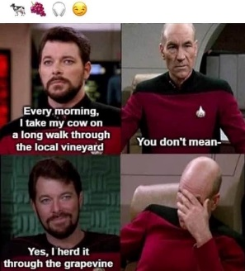 | 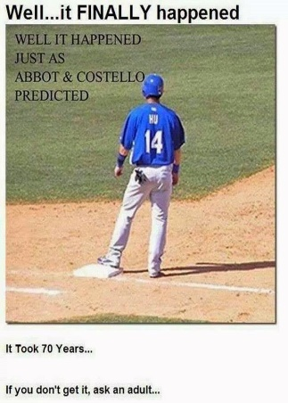 | VISIT US ON OUR  WEBSITE:  www.brooklettsplace.org  VISIT US ON FACEBOOK AT  BROOKLETTS PLACE – TALBOT SENIOR CENTER

BROOKLETTS PLACE – TALBOT COUNTY SENIOR CENTER – APRIL 2024
400 BROOKLETTS AVENUE * EASTON, MD 410-822-2869
OUTINGS & EVENTS:
Monday, April 8 - (12:15 p.m. – 1:00 p.m.) Lunch & Learn w/Melanie. University of Maryland Shore Regional Health presents: Nutrition & Medication 101 with Melanie. Join Melanie Chapple, Pharm-D, transitions pharmacist at the Easton, Dorchester & Chestertown hospitals of Shore Regional Health as she gives tips on medication safety, medication organization and cost savings. A two-week advance sign-up is required for lunch or you may bring your own.
Tuesday, April 9 - (12:15 p.m. – 1:00 p.m.) Carpe Diem Arts presents LENA SEIKALY/Arab American Heritage & Jazz Appreciation Month. Jazz vocalist Lena Seikaly bids homage to her Palestinian roots, while celebrating the Great American Songbook. Made possible by the generous support of the Talbot County Arts Council with revenues provided by the Maryland State Arts Council, the Mid-Shore Community Foundation (MSCF), Dock Street Foundation, Artistic Insights Fund, Brookletts Place, and by individual contributions to Carpe Diem Arts Outreach Fund c/o MSCF. A two-week advance sign-up is required for lunch or you may bring your own.
Wednesday, April 10 – (11:30 a.m. – 1:00 p.m.) Dutch Lunch Out “Chili’s” 28587 Marlboro Ave., Easton, MD Bus will leave Brookletts Place 11:15 a.m. and return 1:15 p.m. Advance signup is required as space is limited.
Thursday, April 11 – (12:00 p.m. – 1:00 p.m.) Lunch/Music with Gene Edwards Review digital keyboard and vocal music, featuring a full array of amazing hits. Advance sign-up for lunch is required 2 weeks in advance or you may bring your own lunch.
Monday, April 15 - (12:15 p.m. – 1:00 p.m.) Lunch & Learn w/Bank of America. Scammers are learning new ways to scam innocent people every day. Please join us as Bank of America shares valuable information about scammers. A two-week advance sign-up is required for lunch or you may bring your own.
Tuesday, April 23 – (12:00 p.m. – 1:00 p.m.) Lunch w/DJ CHUCKIE LOVE Come out and enjoy the sounds of DJ Chuckie. A 2 week advance sign-up for lunch is required by April 9th or you may bring your own lunch.

UPCOMING TRIPS: 2024/2025 Travel Log is available!! Please visit our website www.brooklettsplace.org
FREE PROGRAMS: Advance sign-up requested for most programs – PLEASE NOTE – IF YOU SIGN UP FOR ANY OF THE FREE PROGRAMS THAT HAVE SPACE LIMITATIONS AND ARE UNABLE TO ATTEND, PLEASE BE COURTEOUS AND CALL TO LET US KNOW BECAUSE SOMEONE ELSE CAN BE PUT IN YOUR SLOT. ADDITIONALLY IN SOME CASES A FEE MAY APPLY FOR NO SHOWS!!
- Every 1st and 3rd Monday – (10:30 a.m. – 11:30 a.m.) Music With Melanie – Come sing & play along to familiar favorites. Enjoy music activities that bring us together with shared experiences. Advance sign-up is required.
- Tuesday & Thursday through April 18th– (10:00 a.m. – 11:00 a.m.) “Bingocize” Come out and enjoy a 20 sessions program at Brookletts Place Combining Bingo, Education & Exercise to Improve Your Health. Advance registration is required as space is limited.
- Tuesdays (1:00 p.m. – 2:30 p.m.) Basic Computer Classes w/TCFL– Learn how to use a mouse & mouse pad, Keyboard skills, Microsoft 365, email and much more. Advance registration is required as space is limited.
- Monday, April 8 - (10:00 a.m. – 11:00 a.m.) Join us for Crafting with Tonia “Bird Houses”. Limited to 10 participants – Advance sign-up is required.
- Wednesday, April 10 – (10:00 a.m. – 11:00 a.m.) Join us for a hands-on stress awareness workshop w/The Sound Practitioner. Learn some therapeutic ways with managing stress in a fun and friendly atmosphere. Advance registration is required as space is limited.
- Thursday, April 25 - (10:00 a.m. – 1:00 p.m.) Elder Law Clinic Attorneys will be present (by appointment only) to discuss legal issues pertaining to seniors to include: Elder Abuse, Adult Guardianship; homeowner and consumer related issues and much, much, more. Contact Shore Legal Assets (previously known as Mid-Shore Pro Bono) at 410-690-8128 for an appointment or additional information.
- Tuesday, April 30 – (10:00 a.m. – 11:00 a.m.) “Positive Music w/DJ Randy P”. Reduce your weekly stress by enjoying a fun, safe, and positive musical experience in a motivational environment.

SELF-PAY CLASSES: SPACE AVAILABLE IN ALL CLASSES.
- Advance Beginners Watercolor - Every Monday (11:00 a.m. – 1:00 p.m.) $50.00 per 4 week session. New students are welcome, contact Diana Evans, Instructor 443-239-0657
- Guitar and Ukulele Lessons with Emma Bailey of Mike Elzey Guitar. Every Monday (1:00 pm – 2:00 pm) $5.00 per session
- Beginning Oil Painting – Every Wednesday (9:00 a.m. – 12:00 p.m.) $5.00 per hour. NO CHARGE for SUPPLIES for first three sessions. New students are welcome. Contact Jane Bollman, Instructor at 410-770-8611 or bollman@goeaston.net for additional information or to register.
- Tai Chi W/Nathan – Every Monday & Friday (11:00 a.m. – 12:00 p.m.) You will be introduced to the lifestyle wellness system of Taijiquan, which has promoted the health of millions around the world for a long time. People have experienced their balance improving, their respiratory and cardiovascular health improved, connection with new friends expanded, better sleep, and mental focus. Comfortable clothing and sneakers recommended. $8.00 per-person per class

OTHER PROGRAMS:
- Mondays - (9:00 a.m. – 10:00 a.m.) and Thursdays (8:30 a.m. – 9:30 a.m.) HEALTHY LIVING FOR OLDER ADULTS—SAIL (Stay Active & Independent for Life) Advance registration is required as space is limited.
- Yarn & Needle Group – Every Tuesday 12:30 p.m. If you knit, crochet, needlepoint, felt or weave, this is the Gathering for you. Practice your craft and bring your skills to others for a hour or two. No registration necessary, just drop in. Call 410-822-2869 for more information.
- Blood Pressure Screening – 1st Wednesday of each month at 10:00 a.m.
- Video (Wii) Bowling - Every Wednesday 10:30 a.m. in the TV Room. Come Join the Team. New Members Are Welcome!
- Sho Go Mobile is bringing the market to Talbot Senior Center, Thursdays 10:00 am to 11:00 am. The bus will be stocked with fresh produce, soup, salad & sandwiches from Shore Gourmet! Make sure to take advantage of the convenience of our mobile market!
- Elder Law Clinic – Every 4th Thursday 10:00 a.m. – 1:00 p.m. BY APPOINTMENT ONLY Contact Shore Legal Assets (previously known as Mid-Shore Pro Bono) at 410-690-8128
- Poetry at Noon – Every 2nd Friday

