SIGN UP SHEET 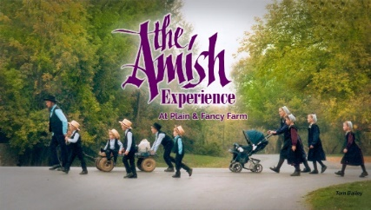 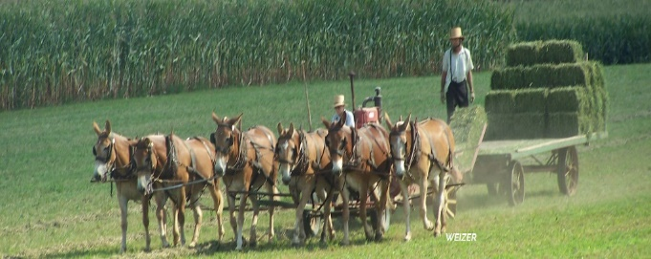
THE AMISH EXPERIENCE – AMISH ARTISANS, BIRD-IN-HAND, PA
TUESDAY, JUNE 6, 2023

$160.00 per person. Who doesn’t like to shop? And who doesn’t like free gifts? Combine the two as we travel off-the-beaten-path through spectacular farmlands to four special Amish stops. Collect a gift at each place we visit beginning with mini soap gift bag. Along with a step-on guide, we will enjoy a Whoopie Pie at BIH Bake Shop, an In-Home Meal with the Lapp Family at their home, An Amish-made toy gift at Lapp’s Toys. Followed by a stop at Forest Hill Leather, and a final stop at Smucker Quilt Shop. The bus will leave Kohl’s parking lot 7:00 a.m. and return approx. 7:00 p.m. (All times for departure are subject to change) DEPOSIT OF $80.00 IS DUE ASAP WITH FINAL PAYMENT DUE BY MAY 5, 2023.
THE BUS WILL WAIT FOR NO ONE!!!!!!!!
Please complete the below form and return with FULL payment to be included on this trip. If bus is full you will be placed on the waiting list.

Last name/first ___________________________________________
Cell Phone ______________________________________________
Date of birth_________________________
Address___________________________________ Apt #_________
City____________________ State______ ZipCode _________
Spouse name___________________________ Phone _______________
Date of birth_____________
EMERGENCY CONTACT _____________________________________
Phone ______________________________________
EMERGENCY CONTACT _____________________________________
Phone ______________________________________

CANCELLATION & REFUND POLICY: Money will not be refunded unless someone takes your place and after trip is taken. If the trip is cancelled for lack of sufficient interest, the refunds will be made promptly.

